Akwl kwlj AwP AYjUkySn Pwr ivmYn PiqhgVH CMnW(sMgrURr)
bI.AYf.dw nqIjw PkBdko ਰਿਹਾ।
Akwl kwlj AwP AYjUkySn Pwr ivmYn PiqhgVH CMnW (sMgrUr) dw bI.AYf smYstr ਤੀਜੇ dw nqIjw ਸ਼ਾਨਦਾਰ irhw[pihly sQwn qy srbjIq e"o ny 86% AMk pRwpq kIqy, dUsry sQwn qy mnIsw Qwpw ny 85.33% AMk pRwpq ਅਤੇ qIsry sQwn qy rIAw B/ 85# nze gqkgs ehs//. ਸੰਸਥਾ ਦੀ ਮੈਨੇਜਮੈਂਟ Aqy ipRMsIpl ਮਿਸ.ਦੀਕਸ਼ਾ v`loN ividAwrQIAW dI kwrgujwrI leI ividAwrQxW Aqy stwP nUM vDweI id`qI ਗਈ[

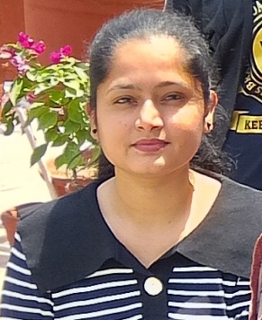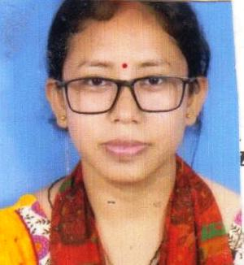
srbjIq e"o mnIsw Qwpw rIAw
pihlw sQwn dUsrw sQwn qIsrw sQwn
86% 85.33% 85#

